**Earthquake resistant structures**

The structure can be made earthquake resistant by using specially designed trusses and base isolation method.

Analysis of structure was done using software STAAD Pro. The prototype was tested on an earthquake simulator machine, and it has an axial load-bearing capacity of more than 100kg

. 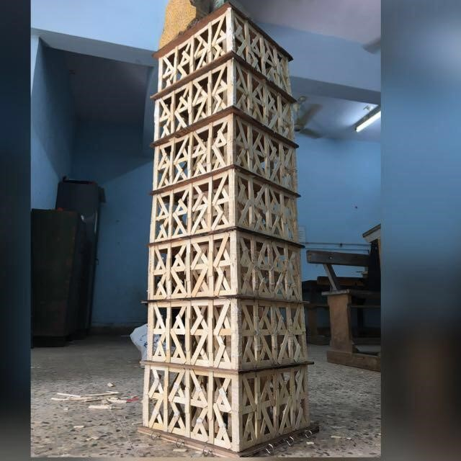

**Sustainable building**

Sustainability may be defined as meeting the needs of present generations without compromising the ability of future generations to meet their needs.

The building was planned in such a way that it could utilize natural resources (sunlight, wind, rainwater) and waste materials from industries effectively. Also, the water, electric energy is conserved and optimized efficiently. 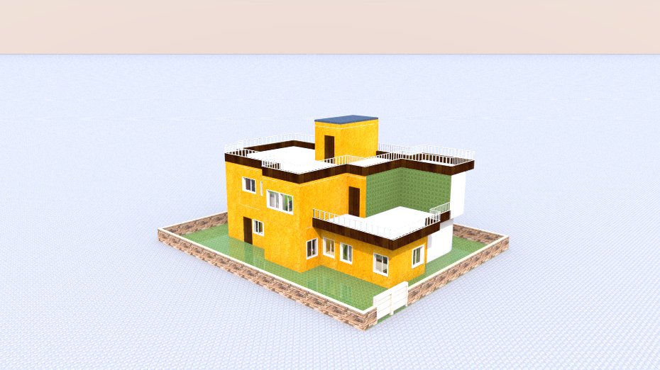

**Bridge Designing**

A cable-stayed bridge was designed and analyzed using software Sap2000. Load testing of the prototype was also done, and it can carry a static load of 2200 kg.

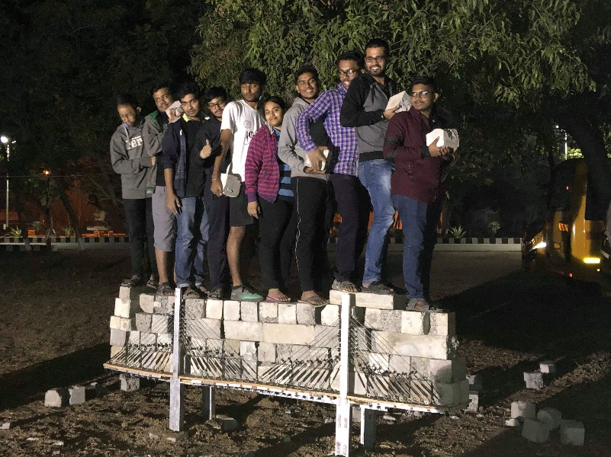

**Geodesic dome**

Two frequency(2v) fuller dome was designed on software SketchUp and prototype of the same has been built by using the hollow aluminium struts.

It can sustain load up to 50 kgs.

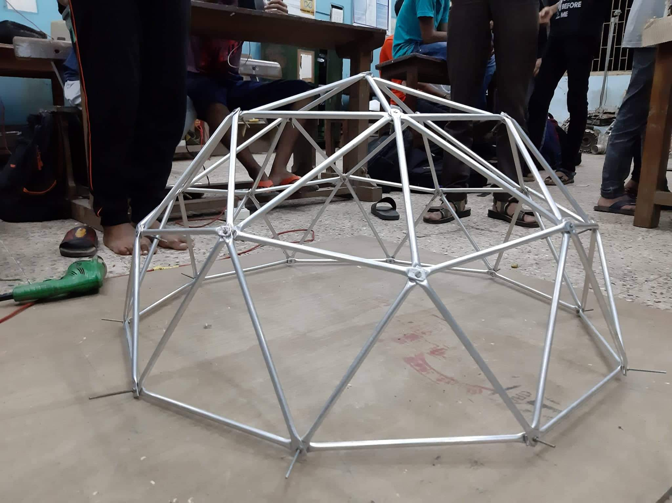

**Tensegrity dome**

The purpose was to build a dome using the principle of tensegrity (in which cables are responsible for taking tensional load and struts compressional load).

Three layers of decagon have been built by using aluminium struts and nylon threads.

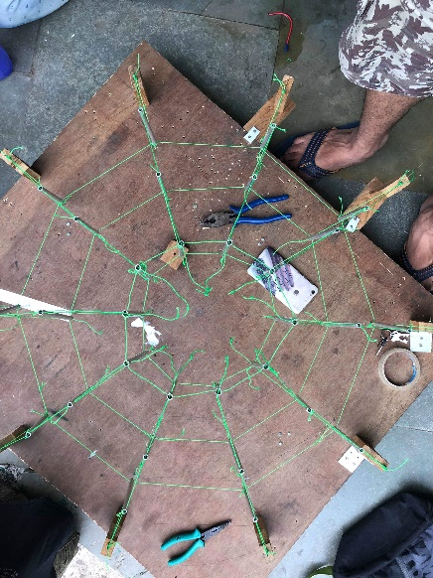

**Diagrid structure**

A diagrid structure consists only of diagonal columns with an optimum angle ranging from 65o-75o.

The 4-8-4 symmetric configuration has been analyzed on software STAAD Pro and prototype can sustain the load of 80kg.

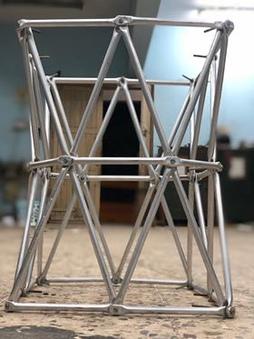

**Truss bridge**

Pratt type truss bridge has been analyzed on STAAD Pro, and it can carry load up to 70kg,which is made using aluminium L section.

